HRM6005 - Managing and Rewarding Performance

Description
Motivating and rewarding employees provides benefits not only for the employee but also the organisation. These are important aspects of performance management, a process that is required to obtain the best from employees, provide a stimulating and interesting work environment and achieve organisational goals. In this unit, students explore the processes involved in managing employee performance within an organisation from both an individual and team perspective.

1.1 Get to know your Assessment 2 project group

Purpose
You will be working with your project group over weeks 1 and 2 to develop a presentation for Assessment 1.
Task
Each project group has its own dedicated discussion board, which can be accessed below. Visit this to introduce yourself to the rest of your group and organise your first meeting.
You can use any method to coordinate and communicate with your team - you don't need to use the discussion board after the initial meeting.
Click here for an overview of Assessment 2.

1.2 Performance management systems
Purpose
Performance management systems, like any systems, contain a set of principles and procedures that determine the way something is done. The aim of the activity is to become familiar with a PMS by examining its components.
Task
Step 1: The image below presents an outline of the various components that make up a PMS. Click on the hotspot in each component to reveal an explanation of that PMS component.
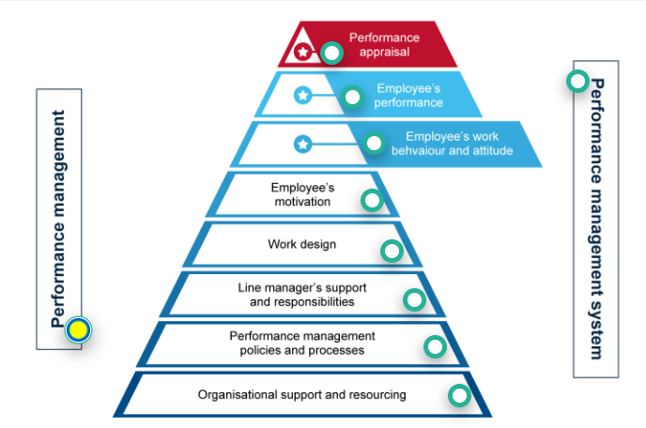
Calude: The following descriptions are what is clickable in the above image. Display them like definitions within the topic.
Performance management – isn’t the whole thing ‘performance management’? Yes and no! ‘Performance management’ can also refer to the action of a manager ‘managing’ the performance of an individual or team (that may not be performing) vis-à-vis: “I’m going to ‘performance manage’ them to success!”
In essence, when someone isn’t performing a manager may adopt a formal ‘performance improvement plan’ – which is generally a negotiated set of actions that the employee and manager agree on, so as to get the employee’s output and/or behaviour back into appropriate alignment. This action is also referred to as ‘performance management’ – though in this case, it is framed in the negative.
Managing underperformance needs to be done in a way that is appropriate and fair, and there is legislation to govern this. For your own reference, you may want to read the relevant section on ‘managing underperformance’ provided by the Fair Work Act - https://www.fairwork.gov.au/employment-conditions/performance-in-the-workplace#what-is-underperformanceLinks to an external site..
Clade: This is an important summary of the legal framework in AUS, that can be applied across the whole unit.
Note: Summarised legal framework
Here's the key legal position from Fair Work:
Underperformance = not doing the job properly, breaching policies, or unacceptable/disruptive behaviour. It's distinct from serious misconduct (safety/reputation risk, or deliberate incompatible behaviour) — that's handled differently, via notice and final pay.
Process an employer should follow:
- Check the award, agreement, contract or policy first for any specific rules.
- Hold a private meeting — explain the issue, offer a support person, agree on clear improvement steps, document it.
- If needed, issue a written warning — clear reason, documented details, clear expectations, fair and reasonable.
- Follow up with regular check-ins.
- If no improvement, consider another meeting, further warning, changed duties/training, or (as a last resort) termination.
Key legal point: there's no fixed rule requiring 1 or 3 warnings before dismissal — but the employee should generally get a genuine chance to improve. If they're later dismissed and claim unfair dismissal, the Fair Work Commission considers whether this process was followed.
Best practice tip
Employers should consider creating and sharing with employees a written performance management policy. The policy should outline what underperformance is, how underperformance will be managed and the possible consequences of underperformance. Employers should also make sure they keep the policy up to date and apply it consistently in the workplace.
A policy can help to make clear what the employer’s and employees’ expectations and responsibilities are and what can happen if underperformance occurs. It can also help prevent employees feeling they’ve been treated unfairly if an issue does come up.

Performance management systems – encompasses everything! The main emphasis on a performance management system is on the policies and processes, importantly however, it needs to be appropriately resourced by the organisation.
By conceptualizing performance management as a multi-level system – from the organisation (macro) to the manager (meso), to the employees (micro), senior managers can see where there may be particular strengths or weaknesses in the system, and put in place interventions to improve things. For example, senior managers may get a report noting that female employees receive fewer financial bonuses than their male equivalents – and they can investigate whether there are gaps in the way performance is being measured, or inherent biases present in line managers, or poorly worded policies or processes etc.
Performance management systems are sometimes classed as being ‘formal’, or ‘informal’ – but in truth, or systems have elements of formal (bureaucratic) and informal practices. Some may be more formal than others.

The performance appraisal – is the most ‘visible’ and ‘applied’ element of a performance management system. Simply, a performance appraisal is a process whereby an employee (usually) sits down with their manager, every six months or on an annual basis, and receives feedback about how they have performance.
This sounds simple enough, but as we will discover in the unit, the performance appraisal never quite captures a full account of the actual performance of an employee, and can be subject to significant bias, which can make the whole process disempowering and ironically, de-motivating.
At the same time, the performance appraisal process is an important step to ensure that an employee is doing the job they are paid to do. Finally, performance appraisals in some contexts may have a dedicated section that gives an employee an ‘overall score’, and also (potentially) a stated financial bonus or reward. However, whether an employee receives a reward or not is very much tied to their work context.

An employee’s performance is the full account of an employee’s output, both good and bad. Over the course of a year, it would be normal for an employee to have ‘a few success stories’ – where they have overdelivered on a target or ‘key performance indicator’ (KPI). At the same time, some KPI’s may have been too ambitious (often referred to as ‘stretch goals’), and they may not have been achieved, or achieved in full. It is normal that performance encompasses both success and failure – but ideally, the scale is tipped much more towards success column.
Performance is usually measured on reductionist, quantitative metrics – profit generated, widgets created etc. etc. In more and more work contexts, such quantitative measures are a poor reflection of what performance is, and occasionally narratives or case examples of employee performance are used as discussion points in the appraisal process. Notwithstanding, there remains a normative desire to quantify output, whether this is appropriate or not.

An employee’s work behaviour and attitude is an account of how they ‘operate’ at work. Some organisations place great emphasis on people dressing professionally, being on-time, being seen to work diligently etc. Other organisations can be more results-oriented, and give staff great freedom to express their personalities, dress-styles, moods etc. as they see fit. Importantly, sometimes great performers can have negative work attitudes and poor behaviour.
Equally, poor performers may present with the right ‘look and feel’ (i.e., they reflect the work culture appropriately). Accounting for an employee’s work behaviour and attitude, whether good or bad, is important to consider while evaluating performance/output – to ensure that bias isn’t negatively affecting the result. Employees may also have pathological behaviour and conduct corrupt, inappropriate, or negative work acts such as bullying, sexual harassment, embezzlement of funds etc.
Irrespective of how good they are at performance, one of the roles of Human Resource Management is to keep such behaviour in check – mitigate it from happening where possible and apply disciplinary actions where it is uncovered.
Employee motivation captures the things that drive an employee to work. Motivation is a complex thing – influenced by the self (i.e., the employee themselves), the organisation and job design, as well as the reward and recognitions structures that are put in place to drive employee’s efforts and behaviors towards certain actions.
We will do a deep dive into employee motivation concepts and theories in week three.

Work design (also known as job design) – has a huge impact on employee motivation and ultimately performance. It can be quite technical, but work design captures how, when, and where, a person undertakes their work.
It captures things ranging from the tasks that person does, the tools they use to do it (such as computers, phones, internet etc.), the hours they work, the regularity of work etc. etc. When exploring work design, we often use the Job Demands-Resources Model.
Line manager support – it may seem like a small thing, but studies show that the way that a line manager engages with their employees can predict between 50-80% of employee performance. Line managers have a fundamental role in negotiating and setting goals with their staff, and then monitoring and appraising their performance (against these) over time.
However, there is an obvious power difference in the relationship between line managers and their employees, and for this reason - biases, power struggles, politics, personality pathologies and office dynamics can get in the way of a constructive, supportive, and effective relationship.

Performance management policies and processes - In essence, most large organisations will have a performance management policy, and associated processes – it will be a set of formal parameters that articulate who does what to ensure that performance against goals are being effectively set, monitored, and ideally, are being met.
The policies will detail processes for managing underperformance and employment termination. The policy may also detail actions related to employee misconduct – or such considerations may be dealt with in a separate policy (such as a code of conduct policy).
Employee performance is (sometimes) linked with their (appropriate or inappropriate) behaviour - and thus, misconduct and underperformance are sometimes considered in tandem.

Organisational support and resourcing – it is fair to say that many organisations have performance management policies and resourcing, however, not all organisations will perform! Importantly, for a performance management system to really work, it needs to be appropriately resourced – thus, there needs to be consideration as to the remuneration of staff, bonuses, other non-financial incentives, training for managers and employees, etc. Without this organisational support, irrespective of how good ‘on paper’ any performance management policy, process or action is, it will fail.

Step 2: In your Orientation Week, you should have set up your personal learning journal tool. If you haven't done so, go to your learning journal orientation page and do so now.

Step 3: Discussion boards will be our way to share our ideas with each other. Here is your first discussion board task.

Optional Additional Reading
Schaufeli, W., & Taris, T. (2014). A Critical Review of the Job Demands-Resource Model: Implications for Improving Work and Health. In Bridging Occupational, Organizational and Public Health: A Transdisciplinary Approach (pp. 43–68)
Chapter 4 A Critical Review of the Job Demands-Resources Model- Implications for Improving Work and Health.pdf
Article Summary:
Job Demands-Resources (JD-R) Model — Summary
Core idea: Two processes drive employee wellbeing:
- Health impairment process: High job demands → strain/burnout → health problems
- Motivational process: High job resources → engagement → positive performance outcomes
Job demands = aspects requiring effort with physical/psychological costs (workload, conflict, job insecurity).
Job resources = aspects that help achieve goals, reduce demands, or drive growth (feedback, autonomy, support).
History
- 2001 (Demerouti et al.): Original model, focused on burnout only.
- 2004 (Schaufeli & Bakker): Revised model added work engagement as the positive counterpart to burnout.
- Later extended to include personal resources (self-efficacy, optimism, resilience) — these can directly boost wellbeing, buffer demands, mediate resource effects, or shape how people perceive their job.
Evidence
- Strong, consistent support across countries/industries (cross-sectional and longitudinal studies).
- Resources reliably predict engagement; demands reliably predict burnout.
- Some evidence of reciprocal causation — engagement can also build future resources ("gain spirals").
- Interaction effects (resources buffering demands) are real but weaker than the direct/main effects.
Six Unresolved Issues (the "critical" part)
- Epistemological status: It's a descriptive/heuristic model, not explanatory — it doesn't say why specific resources work, just that demands cost and resources help.
- Demands vs. resources isn't clean: e.g., a "challenge" demand can motivate; a "resource" can feel threatening. Authors suggest redefining by valence (negatively vs. positively valued), not just category.
- Personal resources' role is inconsistent — used as mediator, moderator, or third variable across studies, with no settled approach.
- Health impairment and motivational processes may not be fully separate — they seem to interact/overlap rather than run independently.
- Reciprocal causation — demands/resources and outcomes influence each other over time, not just one-way.
- Multilevel issues — applying the model to teams/organizations requires matching the level of measurement (team-level resources → team-level outcomes), which many studies get wrong.
Practical Value
The model's flexibility is its main strength — it can be tailored to any workplace (different demands/resources/outcomes per industry). The authors describe a real-world tool, the JD-R Monitor, used in an 8-step cycle: define problem → design survey → communicate → run survey/give individual feedback → analyze/report → discuss results → intervene → evaluate and repeat.
Bottom line: JD-R is popular because it's broad and practical, but that breadth means it lacks precision — using it well requires pairing it with more specific psychological theories to explain why particular demands/resources matter in a given context.
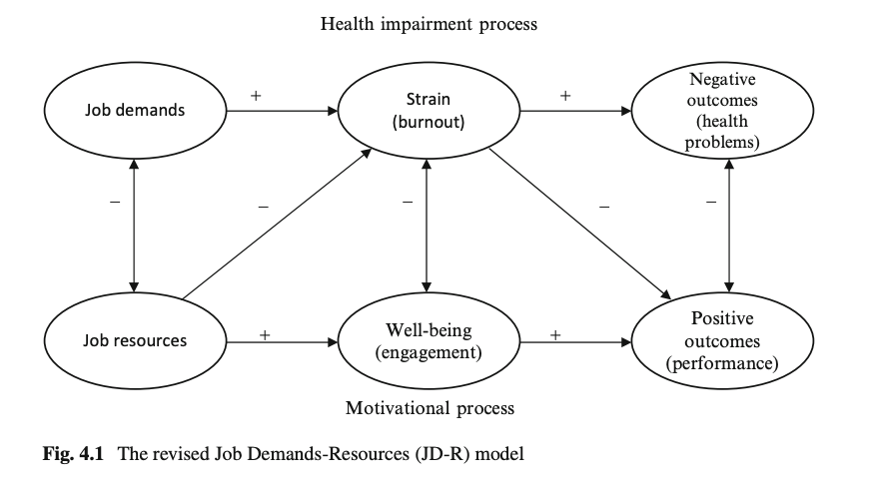

My notes from Week 1:
  - the way that a line manager engages with their employees can predict between 50-80% of employee performance
  - Effort Reward Imbalance (ERI) model
  - The revised JD-R model included work engagement in addition to burnout and considered burnout and work engagement to be mediators of the relation between job demands and health problems, and job resources and turnover intention, respectively
  - Work engagement refers to a positive, fulfilling, work-related state of mind that is characterized by vigor (that is, high levels of energy and mental resilience while working), dedication (referring to a sense of significance, enthusiasm, and challenge), and absorption (being focused and happily engrossed in one’s work).
  - burnout will lead to health problems, such as depression, cardiovascular disease, or psychosomatic complaints
  - Job resources have inherently motivational qualities (effort-recovery theory)
  - Offering many resources fosters workers willingness to dedicate their efforts and abilities to the work task (extrinsic motivation).
  - The also play an intrinsic motivational role because they satisfy basic human needs for autonomy and relatedness.
  - Personal resources = psychological characteristics or aspects of the self that are generally associated with resiliency and state management (inner game).

1.3 Performance management—a multi-level interpretation
Purpose
At a conceptual level, understanding how an organisation develops strategies and how these strategies translate into employee actions at the bottom of the hierarchy are important for seeing how PMSs work in practice. This task provides you with the cognitive tools to conceptualise organisational actions from the macro to the meso and the micro then back again.

Task
Step 1: Let’s get high level! Before clicking to reveal the text, consider the questions.
Why do we work?
Rather than being a rhetorical question, the purpose of asking why we work is an important one. We need to ask that to understand why we have organisations and why we have departments, teams, bosses, colleagues, targets, objectives, computers, the internet, etc. Organisations have emerged, particularly within the last 800 years, for specific purposes and generally to create value of some kind (money, profit, societal health, knowledge, faith, etc.).
Where does the notion of a company come from?
The word ‘company’ was derived to describe a group of wheat farmers who worked on the island of Sardinia. The biggest trading bloc at the time, the Genovese, whose court was in Florence, Italy, sent their ships over to Sardinia each year to collect wheat from the farmers. The Sardinian families realised they could negotiate a better deal for their wheat if they combined forces and undertook negotiations as a collective. The term company is derived from ‘com’, which is Latin for ‘with or together’, and ‘pania’, which means 'the making of bread'. The Sardinians' organisation was derived to create value from making bread. The etymology of the word ‘company’ gives an indirect answer as to why work and organisations exist.
How does purpose fit in?
Knowing that all organisations exist to create a particular sort of value is key to understanding how work is structured and how we measure whether that work generates the desired value (i.e. performance management). This conceptualisation is also important because it allows us to consider the macro force of the organisation itself and the role of micro forces, such as employees, in generating outcomes.

Step 2: Next, you will examine two management styles known as the top-down and bottom-up management approaches.
Look at the diagram below to get a quick insight into these approaches.
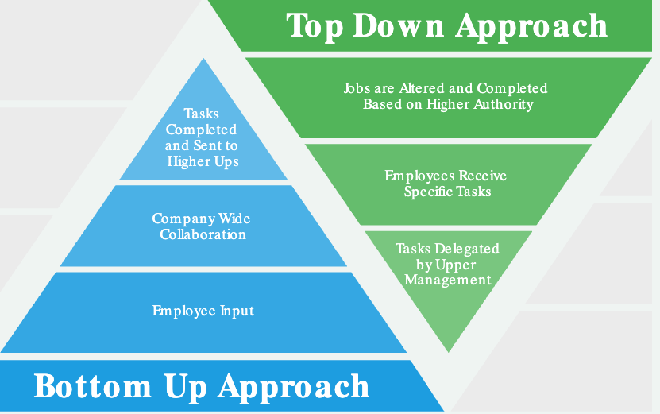

Now, read Lee (2021) Top-down or bottom-up management: Which is best for your business?Links to an external site. to gain further insight into what each approach involves and their respective pros and cons.

Step 4: Read on to see how this all ties in to performance management.
Use the arrow keys to navigate between slides. After selecting a slide, use the Tab key to move to the slide content.
How do the top-down or bottom-up management approaches fit in with performance management?
Generally, organisations form strategies from the top-down but also have important feedback loops (called heuristics) for getting new ideas from employees at the bottom of the hierarchy and championing them up the line.
However, when it comes to performance management, it is almost always a top-down process. Performance management starts with senior leaders setting broad targets for the organisation as a whole and also often for each division or function of their organisation. This is termed a ‘strategy.’ A strategy generally has a set of objectives, which are statements that articulate the desired functional performance outright or relative to competitors. Objectives also have KPIs, which are quantifiable metrics that, if achieved, show evidence that the objective has been met.
How are KPIs used in performance management?
Division managers receive the objectives and KPIs, decide which KPIs should be allocated to which work team, and then pass these on to the specific team leaders. Team leaders then bring their specific KPIs into the performance planning meetings they have with their staff and apportion the specific targets and goals to specific team members. It all sounds a bit complex, but assuredly, this is bureaucracy in action!
The above description, while broadly accurate, does vary across different organisational contexts and industries. What performance is in some organisations is difficult to quantify or make tangible, particularly in knowledge-intensive and service sectors, such as education, health and scientific research. For example, a nurse can’t be told at the start of the year that they need to save 100 people’s lives. Instead, they are given goals that dictate how they should treat patients and how they should effectively deploy their time while at work.
It is important to note that performance goals are generally set from the top-down. However, performance usually cascades up. Individual employees do their work, which combines with the output and performance of the team in which they are nested. In turn, this cascades up and combines with all of the work output of teams within a specific division, and, finally, the divisional performance is aggregated to represent the organisation’s overall performance.

Step 5: For your purposes in your learning, have a go at drawing a flow diagram that shows how goals and KPIs flow from the top of the organisation down to the employee and how performance cascades from the employees to the whole organisation.

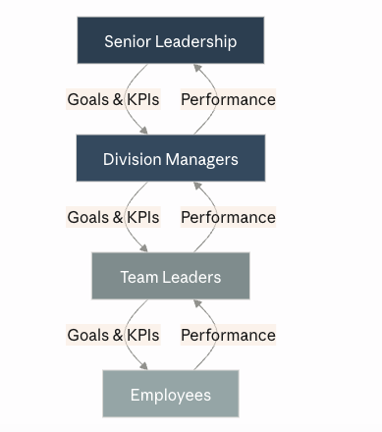

1.4 Performance management—a process
Purpose
Performance management systems involve a series of components that interlock to manage performance. The act of performance management should also be conceived of as a flow or cycle. In this activity, you explore a process (or flow) model of performance management.

Task
Step 1: A well-designed and executed performance management process has a flow-on effect from the employee to the manager, team, and ultimately the organisation. Look at the individual processes below, then click and drag them to the order that you think best fits a performance management process as a whole. In step 2, you will see the suggested correct order with explanations.
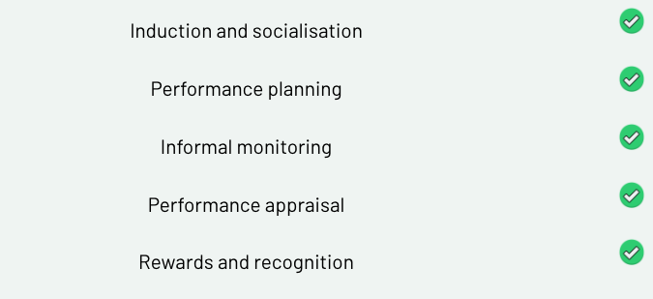

Step 2: Click below to see the appropriate order of the processes with an accompanied explanation.

Let’s explore these steps.
Induction and socialisation—This happens in the first few days, weeks and months of a new employee joining an organisation and workgroup/team. It involves informal and formal elements. Formal elements usually include a sit-down meeting with an employee’s line manager, where broad expectations and organisational supports are outlined. Informal engagement comes in the form of interactions with peers and observations by the employee of other workers, where they figure out the work culture or how things get done in their new context. Induction and socialisation are important for setting the scene and orienting the employee to the written and unwritten rules of the place.
Performance planning—Performance planning is a regular, formal process that typically occurs between an employee and their line manager even though other workplace documents that stipulate performance benchmarks may also shape this process. In essence, a manager and employee decide on and negotiate specific goals for an employee to deliver on, then stipulate when these goals must be delivered. Performance planning might happen annually, every six months or perhaps even more frequently, depending on the work context. Noting again that, while this step involved the negotiation of goals, the power difference between an employee and their manager means that the process is open to abuse, coercion, corruption and unfairness. The fact that the process usually occurs behind closed doors can also lead to issues of inequity (i.e. where one employee feels that their targets are more insurmountable than those of their colleagues, even those who are paid more).
Informal monitoring—This step isn’t always conducted. However, there is a general expectation that managers will check in on their staff and monitor how they are progressing on their set goals. Of course, this can be done in a supportive, collaborative and positive way. It can equally be conducted through more malicious forms of surveillance and micromanagement. The latter actions have proven to be detrimental to employee performance, particularly because they strip employees of autonomy in deciding how their work gets done. Thus, informal monitoring can be a fraught step. If done incorrectly (even unintentionally), it can undermine the purpose for which it exists.
Performance appraisal—Every six or twelve months, an employee sits down with their manager and examines their performance against previously defined goals. This is necessarily a formal process, and, indeed, it can be subject to legal deliberations, so some account of the appraisal is generally recorded. There is much to unpack concerning to the performance appraisal process, and we will learn more about this specific process next week.
Reward and recognition—In some but not all work contexts, the performance appraisal process may be tied to specific rewards and recognition, particularly in retail contexts where bonuses may be ascribed based on performance. In roles where appraisals do not have an ascribed bonus structure, past appraisals may be tied to promotion opportunities, which generally also increase pay.
A Hidden Step—Career development
During a performance appraisal or separate from it, there is some expectation that managers will offer counsel to their subordinates on their career development. Noting again that the process involves a power imbalance, this role is fraught with tensions. For example, if the supervisor identified that the subordinate is excellent at their job, from an instrumentalist perspective, they have a conflict of interest in ensuring that the employee does not ever leave their division or work function. At the same time, a supportive manager would know that by guiding and positively influencing an employee in the potential next stages of their career and development, they can positively impact their motivation to undertake their current work.
"Bring us back to do"—Performance management is a cycle. When your work has been appraised, performance planning for the next performance cycle happens all over again and so on, until you leave an organisation.

Feedback
The purpose of reflecting on this process is to bring to the consciousness, that which has been unconscious. By exploring how organisational actions (formal and informal) have shaped our feelings, emotions and experiences, we can gain enhanced abilities in planning, strategising and improving our organisations. Thanks for the time you’ve spent reflecting on this.

1.5 Goal setting
Purpose
The purpose of this exercise is to examine goal-setting templates that are commonly used in organisations as part of their performance planning process.

Some context before you begin
There is a motivation theory called goal-setting theory, which states that people who set goals achieve goals, even if they don’t achieve the goals they set out to achieve. (Have a go at memorising that.)
Goal setting has become entrenched in standard organisational behaviour, particularly as it applies to performance management. Let’s explore this further.

Step 1: In every course, workshop or seminar that explores performance management, the topic of goal setting is always given narrow but explicit attention. Generally, it espouses the part of the performance planning process that includes the setting of goals between the supervisor and employee. Such goals should be SMART, an acronym that connotes that a goal should be:
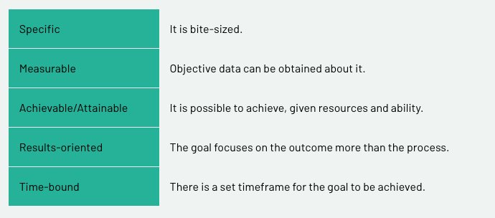

The figure below provides pointers on how SMART goals can provide parametres and eliminate guesswork when defining goals.

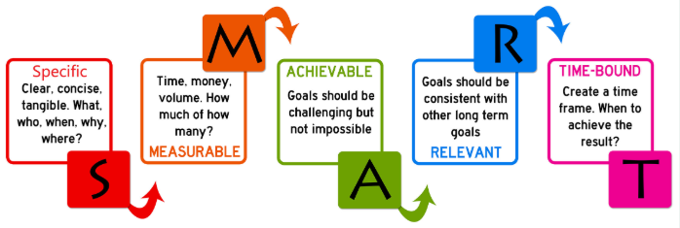

All of these things are true, but they are not the whole truth as to how work is conducted and how work performance is generated. To understand this last sentence, we must delve a little deeper into the critical perspective of performance management.

Step 2: Read through the following SAP article that suggests a breakdown of 10 Ways to Improve the Performance Management Process.Links to an external site.
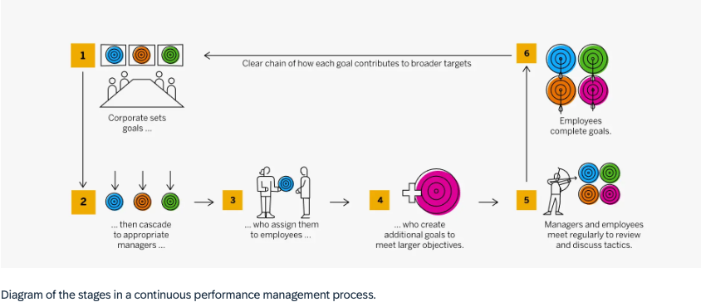
Article summary:
Performance management process (3 stages): plan/set goals → monitor performance → evaluate/recognise. Cycle repeats.
Key differences, continuous vs. traditional:
- Cadence: Traditional = quarterly/annual reviews only. Continuous = ongoing, real-time.
- Goal tracking: Continuous checks off goals as completed, in-system, visible to manager/team in real time — not saved up for a review.
- Cascading goals: Set at corporate level, broken down through functions to individuals; continuous systems let these be adjusted live if strategy shifts, rather than locked for the year.
- Documentation: Continuous captures achievements and 1:1s as they happen, so the annual review "writes itself" instead of a scramble to recall the year.
- Feedback: Continuous = ongoing coaching and feedback loops. Traditional = feedback saved for the periodic review.
Business impact per SAP: better retention, clearer internal mobility/promotion paths, higher productivity, and a more direct link from review to compensation planning — because the data's already there.
One caution from the article: don't jump straight from no process (or traditional) to full continuous overnight — it's a shift best made gradually.

Step 3: More and more, organisations are implementing app-based and computerised performance management systems, and goal setting is often a built-in feature of these. There are many competitor products, and, indeed, you may use such a product presently in your workplace, or you are likely to down the line.
But where do these notions of work, goal setting and performance come from, and are they a true reflection of how work happens?
To shed light on this question, watch the two following short video clips. First, watch Classical History of Management.
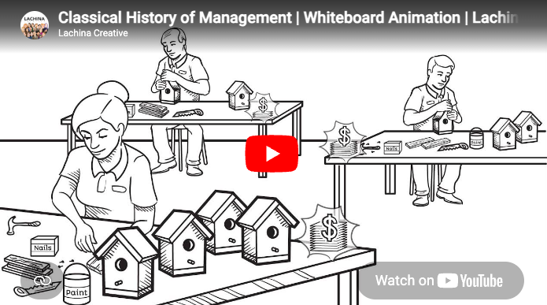
Source: Lachina Creative. (2016, October 12). Classical History of Management | Whiteboard Animation | Lachina Creative [Video]. YouTube. https://www.youtube.com/watch?v=kNrvxh8R1KULinks to an external site.

Now, watch Frederick Taylor | Scientific Management Explained.

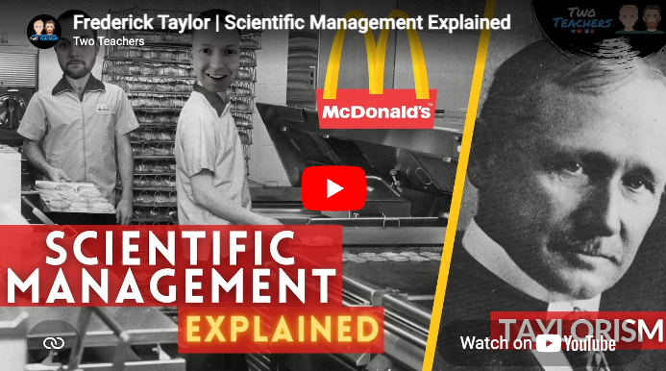
Source: Two Teachers. (2021, January 18). Frederick Taylor | Scientific Management Explained [Video]. YouTube. https://www.youtube.com/watch?v=6O9T7bqGAgILinks to an external site.

Step 5: By engaging with the above texts and videos, you’ve learned how goal setting and SMART goals are tied to a somewhat archaic notion of work, which is termed 'scientific management’ and often referred to as Taylorism. Taylorism has received a lot of criticism with perhaps the most discussed example being how it was applied to the US forces in the Vietnam War by then secretary of state, Robert McNamara. - Robert S. McNamara and the Evolution of Modern Management.pdf
There are many anecdotal examples of poor goal setting applied to work. An often-cited anecdotal example is bus drivers who were paid for arriving at each stop on time, but, in order to do so, decided not to pick up some customers. Another example is truck drivers who are paid for delivering their goods at a set time yet will dangerously race through traffic, drive while fatigued and, as a result, cause accidents.
Most of us will work or have worked in contexts where set goals or performance expectations seem counterintuitive to the actual function of work.
Has a relevant, personal experience come to mind? If so, hold onto that thought.

Step 6: With the notion of counterintuitive goals in mind and possibly some personal experiences that relate to this idea, read this blog post by Ben Taylor (2018) 7 examples of bad goals, and how to fix them.
Step 7: You’ve just read Ben Taylor’s blog, which discussed common mistakes when setting work goals. Did one or more of the seven mistakes resonate with you?
Article summary:
7 common goal-setting mistakes (and fixes):
- Picking numbers on a whim — base targets on past performance, not guesses.
- Ignoring other teams' dependencies — goals should be within your own team's control; if multi-team, agree on top-level objectives upfront.
- Missing a middle step — the path from step 1 to the end result needs to be as clear as the start and finish, not vague in the middle.
- Overly aggressive goals — can demotivate and crowd out other responsibilities; base goals on what's realistically achievable.
- Goals disconnected from org strategy — regularly check goals still align with what the wider business actually needs.
- Too many goals at once — focus on 1–2 big priorities at a time rather than juggling a long list.
- Skipping the review — don't just tick goals off; review what worked/didn't, since that makes setting the next round of goals much easier.

Feedback
Great work! We covered SMART goals in one, quick-action ‘band aid rip’. It is important to understand goal setting, but equally (and as we are about to learn) there are some gaping limitations to it as an approach. As Einstein said, ‘Not everything that counts, can be counted.’

1.6 Performance management—formality
Purpose
The purpose of this exercise is to explore the formality–informality paradigm as it relates to performance management.
Task
Step 1: Correctly identify the following actions as either being formal, informal, or either. Then click to see the explanations below.
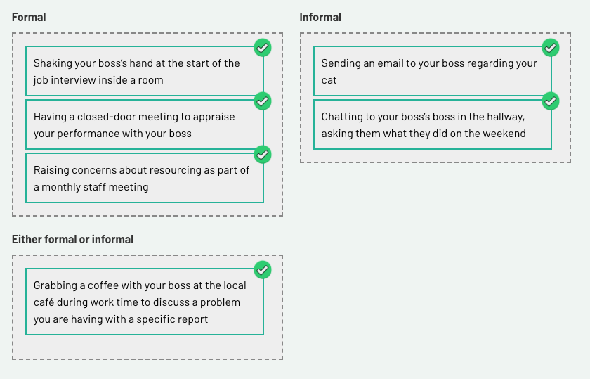

Shaking your boss’s hand at the start of the job interview inside a room
This is a formal process because it forms part of the formal recruitment process. Indeed, if the handshake was considered inappropriate (i.e. it was coerced and/or formed a basis of harassment), this could be used against the boss in legal proceedings. As job interviews are a formal process, all engagements associated with this should be considered formal also.
Grabbing a coffee with your boss at the local café during work time to discuss a problem you are having with a specific report
Generally speaking, having a coffee with your boss outside of a workspace may be considered informal. However, context counts, and, if you are raising issues of pertinent concern to the workplace (such as an ethical issue), it certainly could become a formal meeting. That said, asking your boss for advice, generally speaking, is not necessarily a formal process, particularly when done outside of a performance appraisal process.
Having a closed-door meeting to appraise your performance with your boss
Closed-door meetings and performance appraisals should be considered as part of a formal process of work.
Sending an email to your boss regarding your cat
Any email forms part of a workplace’s communication platform and should be considered a formal action—even if the tone and tenor of the email are lighter and/or informal. Emails can form part of legal or disciplinary proceedings against parties who violate laws or workplace policies regarding appropriate communication.
Raising concerns about resourcing as part of a monthly staff meeting
Any staff meeting, whether minuted or not, is a formal action.
Chatting to your boss’s boss in the hallway, asking them what they did on the weekend
Even if someone is higher than you in the workplace hierarchy, simply chatting to such people doesn’t make the process formal—though, perceivably you will be shaping your interaction according to the status of the other person. Thus, chatting to a superior or a superior’s superior in a social environment at work can be considered informal.

Step 2: The notion of formal and informal processes is likely not new to you, but remember that a given place of employment will generally be comprised of formal and informal processes.
Formal processes are those that may be written down, subject to legal proceedings and/or form part of the standard operations of a particular workplace. At work, a lot of the processes that are undertaken are formal.
Informal processes are those that are considered off the record and are potentially more social. These are essential to a good working environment. An important, humanising aspect of work is when employees feel that they have a voice to unofficially share ideas, concerns, happiness, pain, etc. without the fear that expressing such things would reflect badly on their measured performance.

Feedback
While the performance appraisal process is formal, good managers know that the secret to successfully promoting performance in the employees that they manage relies on setting up effective informal support and communication channels.

Optional Additional Reading
THE ROLE OF INFORMAL AND FORMAL NETWORKS. HOW PROFESSIONALS CAN BE INNOVATIVE IN A CONSTRAINED FISCAL ENVIRONMENT.pdf
Article Summary:
Study: 272 Australian engineers/asset managers (public & private sector) surveyed to test how workplace relationships affect access to resources and innovative behaviour.
Key idea: Alongside the usual formal relationships (supervisor–employee = LMX, employee–organisation = POS), the authors identify a third, informal relationship — ILMX (Informal Leader-Member Exchange) — a bond with a non-line senior manager, often built through shared professional networks outside the direct reporting line.
What they found:
- POS and ILMX both significantly predicted employees' perception of having adequate resources (staff, time, support).
- LMX (direct supervisor relationship) did not significantly predict resource adequacy — surprising, since it's usually the assumed driver.
- Resource adequacy strongly predicted a proactive culture (60.5% variance explained) and, together with that culture, explained 28.1% of innovative behaviour.
- No significant difference between public and private sector employees — the two sectors have converged, likely due to outsourcing and shared accountability pressures.
Practical takeaway: When your direct manager can't or won't unlock resources (due to bureaucracy, budget, or misaligned short-term goals), an informal ally elsewhere in senior management — someone who shares your professional values — can be just as, or more, effective at getting you what you need to be proactive and innovative. Organisations should recognise and support these informal networks rather than relying solely on the formal chain of command.

1.7 Performance management—a critique (part I)
Purpose
What if, in trying to measure an employee’s performance, we were, in fact, negatively affecting it? Does the action of measuring an employee’s performance and potentially assigning them a reward actually stimulate performance? Or is it an ethically ambiguous managerial action that can lead to negative outcomes of biblical proportions like the global financial crisis? The purpose of this topic is to navigate and review a critique of performance management.
Task
*Assessment
This topic requires engagement with three academic texts. The topic and the texts may be directly relevant for your third major assignment. As such, it is highly recommended that you take notes in your weekly learning journal, highlighting and adding written reflections on particular sections of the texts that may pique your interest.
Step 1: Access Qiu, et al (2015), which will provide the basis for the subsequent steps in this activity:
EMPLOYEES' PSYCHOLOGICAL OWNERSHIP AND SELF-EFFICACY AS MEDIATORS BETWEEN PERFORMANCE APPRAISAL PURPOSE AND PROACTIVE BEHAVIOR.pdf
Article summary:
Study: Qiu, Hu, Zhang & Li (2015), Social Behavior and Personality, n=512 Chinese employees.
Question: Does performance appraisal purpose (evaluative vs. developmental) affect employee proactive behavior, and what mediates this?
Key findings:
- Evaluative appraisal (past-focused, tied to pay/promotion) → no direct effect on proactive behavior, but hurts it indirectly by lowering psychological ownership.
- Developmental appraisal (future-focused, training/growth) → direct positive effect on proactive behavior, plus indirect positive effects via higher psychological ownership and higher self-efficacy.
- Self-efficacy boosts psychological ownership, which in turn drives proactive behavior (organizational, interpersonal, and personal types).
Practical takeaway: Appraisals framed around growth/development (not just scoring/ranking) build employees' sense of ownership and confidence, which drives initiative-taking. Purely evaluative, backward-looking appraisals can quietly undermine ownership even without an obvious direct hit to proactivity.
Caveats: Self-report data, single cognitive/individual-level lens, moderate model fit (CFI .882, RMSEA .064) — authors flag need for broader factors (autonomy, culture) in future work.

Definition:
Psychological ownership is a state in which individuals feel as though
the target of the ownership—material or immaterial in nature—or a piece of it,

Step 2: For those unfamiliar or less familiar with academic texts (i.e. most people), this paper will come across as particularly dry and potentially boring. Sorry! The truth is that there is some explicit analysis presented in it, which, if unpacked correctly, calls into question the value of evaluatively focused performance appraisals.
is theirs (Pierce, Kostova, & Dirks, 2001; Pierce, Rubenfeld, & Morgan, 2001).
Turning to the figure on page 1106, please enter the numbers that link the following variables:

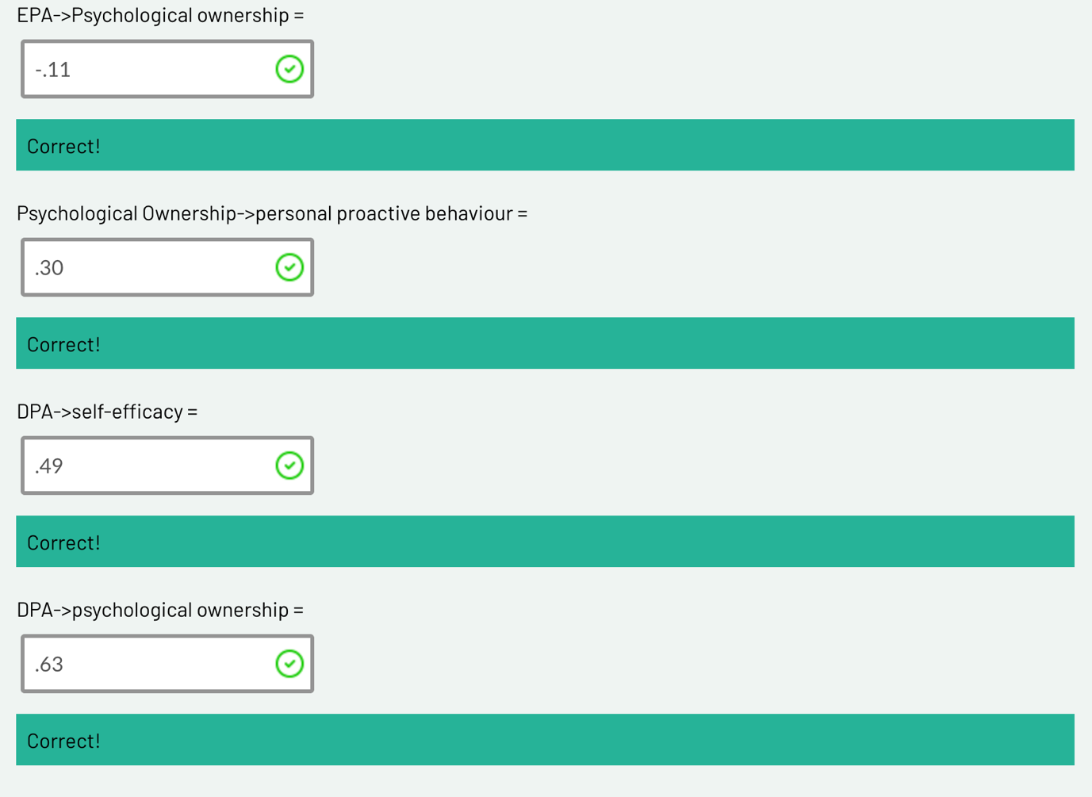

−.11**
This was the relationship linking EPA and psychological ownership. The asterisks mean it was statistically significant—put another way, 95 percent of the time there was a consistent trend present across the sample. The relationship was negative and can be interpreted thusly:
For every one-unit increase in evaluatively focused performance appraisals (i.e. when performance appraisals were more evaluative), there was an 11% reduction in the level of psychological ownership by the employee. In essence, the more evaluatively focused the appraisal, the less the employee/respondent felt that what the appraisal captured was a good reflection of the work they did. Instead, they felt that it measured other things.

.30**
This interaction, which links psychological ownership and personal proactive behaviour, may be interpreted as positive. When people felt psychological ownership over the performance appraisal, it made them more proactive at work, which is, of course, the desired outcome. However, a positive relationship just means that when one variable is high, so is the other variable; equally, if one variable is low, so is the other variable. Thus, if psychological ownership was low (as per the path from EPA), personal proactive behaviour would also be low.
.49**
The link between a developmentally focused performance appraisal and self-efficacy is interpreted as positive (.49 is a big deal in this kind of analysis). It may be understood that developmentally focused performance appraisals were correlated with increased feelings of self-efficacy (belief in one’s ability to achieve their goals).

Summary
This analysis shows us that, when an appraisal is evaluatively focused, employees tend to disassociate themselves from it (reduced psychological ownership). This is a really bad outcome, because psychological ownership is correlated with proactive behaviour, and, thus, a person will be less proactive as a result of their evaluatively focused performance appraisal.

1.8 Performance management—a critique (part II)
Purpose
This activity is a continuation of our research into critiquing performance management.
Step 1: Read the following article:
The Performance Management Revolution - the focus is shifting from accountability to learning. Harvard Business Review, 94(58), 58–67.pdf
Article Summary:
Cappelli & Tavis, "The Performance Management Revolution," HBR Oct 2016
Core argument: Companies are dropping annual appraisals in favor of frequent, informal check-ins — shifting focus from accountability to development.
History (accountability ↔ development pendulum):
- WWI/WWII: appraisals built for weeding out/ranking (military origin)
- 1950s-60s: McGregor pushed employee-led goal-setting; GE split accountability from development discussions
- 1970s-90s: inflation + Jack Welch's forced ranking + exec pay rules + "War for Talent" pulled focus back to accountability
- 2011+: Adobe, then Deloitte/PwC/Accenture/GE dropped annual reviews for frequent feedback
Three business drivers cited:
- Need for faster employee development (esp. professional services)
- Need for agility — goals set annually don't survive changing projects/markets
- Need for teamwork over individual ranking (e.g., Gap, Sears)
Persistent challenges:
- Aligning individual goals with fast-shifting company goals
- Still need a way to reward/differentiate performance
- Identifying poor performers without annual documentation
- Legal/discrimination risk without "objective" scores
- Feedback systems/tech not built for continuous input
- Some firms (Deloitte, PwC, New York Life) reintroduced a "third way" — informal feedback + periodic multi-dimension ratings, after going fully numberless caused problems
Bottom line: Not a fad — driven by real business need for speed and development — but full removal of ratings has proven hard to sustain; hybrid models are emerging.

This pairs well with the Qiu et al. study you shared earlier — that one gives the psychological mechanism (ownership/self-efficacy) for why developmental appraisal works; this one gives the industry trend and practical models companies are using.
Step 2: Cappelli & Tavis (2016) identify three reasons why evaluative performance appraisals have been dropped.
They are:
- a return of people development
- the need for agility
- the centrality of teamwork.
They also identify reasons why there is a temptation for evaluative performance appraisals to be retained, such as that the appraisals:
- align individual and company goals
- reward performance
- identify poor performers
- avoid legal troubles
- manage the feedback firehose.
Based on your reading of Cappelli & Tavis’ article as well as your experience, consider the reasons why performance appraisals have been dropped and if those explanations outweigh the reasons to keep them.

Step 3: Share your thoughts on the question presented in the debate board below. Engage in the discussion by commenting on one or more posts by your peers.
Step 4: Access the following reading:
How Does Performance Management Affect Workers - Beyond Human ResourceManagement and Its Critique.pdf
This is a big reading! If you are struggling, set yourself a goal of finishing up to the end of page 82, which is seven pages in—the essential stuff is in the first six pages. This review paper highlights limitations with research conducted on performance management, particularly the performance appraisal process.
Article summary:
Tweedie, Wild, Rhodes & Martinov-Bennie (2019, IJMR) — literature review on how PM affects workers, across three stages.
1. Mainstream HRM — three phases, each more socially aware but more organization-focused, not worker-focused:
- Phase I (1920s-90s): fixing rating accuracy (trait scales, MBO, BARS) — never solved
- Phase II (80s-90s): PM's "social context" — justice perceptions, fairness — but still to serve org performance
- Phase III: fully integrating PM into strategy/profit — worker wellbeing recedes further
2. Critical HRM (CHRM) — three theoretical lenses:
- Labour process theory (Marxist, Braverman) — PM as class control tool; theorists: Barlow, Newton & Findlay, Thompson
- Foucauldian theory — PM as discursive power that disciplines/subjectifies workers into "docile," self-monitoring subjects; theorists: Townley, Weiskopf & Munro (governmentality/biopower), Rose
- Conflicting rationalities (Habermas) — "relational" (communicative, consent-based) vs "transactional" (instrumental) PM; instrumental logic tends to "colonize" the relational; theorists: Broadbent & Laughlin, Townley et al.
3. Recognition theory (the paper's proposed advance) — two thinkers:
- Axel Honneth: three recognition types — love (self-confidence), rights (self-respect), esteem (self-esteem, tied to work). PM = proxy judgment of a worker's social contribution.
- Christophe Dejours: esteem from management/clients (usefulness) vs colleagues (quality/"beauty"); misrecognition → suffering, breakdown of collegial bonds, even linked to workplace suicides.
Core argument: HRM and CHRM both under-theorize worker wellbeing as an end in itself — HRM subordinates it to org performance, CHRM focuses on power but not psychic harm. Recognition theory fills this gap by giving vocabulary for how (mis)recognition damages/sustains self-identity through work.

Quick connection across your three uploads: Qiu et al. gives the psychological mechanism (ownership/self-efficacy) for developmental appraisal's benefits; Cappelli & Tavis gives the industry trend; this Tweedie et al. paper gives the theoretical scaffolding (including a critique that even developmental/social-context HRM research, like Qiu et al.'s, still frames worker wellbeing instrumentally in service of org goals — that's literally the critique in their Phase II section).

Step 5: In reflection on the previous reading, make the following journal entry.
- Summarise the three phases of HRM research, looking at performance management (each phase summary should be about 120 words).
My notes:
1. Mainstream HRM:
Core question: Does PM help the Org?
This phase of HRM is more organisation focussed, not worker focussed. Research focusses on eliminating measurement error, understanding PM’s social context, and integrating PM into org strategy.
HRM research considers workers perceptions and experiences, but simultaneously leans towards a performative lens.
Overall, worker wellbeing only matters insofar as it affects org performance, never as an end in itself.
2. Critical HRM research:
Core question: Does PM exert power/control over workers?
Applies PM as a disciplinary, coercive or inequitable management device. Generally, ignores employee well-being or employee development.
Critical HRM and PM looks at perceived shortcomings of HRM. CHRM is overwhelmingly qualitative and is viewed as anti-performative.
The three influential critical approaches are, Labour process theory (PM as class control where managers use it to extract more effort from workers), Foucauldian Theories (PM as discourse that shapes workers into “docile”, self-monitoring subjects), and Notions of conflicting rationalities (Distinguishes “relational” PM from “Transactional” PM).
  - Recognition Theory:
Core question: Does PM protect or damage the workers basic sense of self?
Acknowledging (or not) workers contributions, and how this affects their well-being at the level of self. Seen as an overarching aid to prior models.
Authors argue that being properly acknowledged for your woek is essential to psychological wellbeing. Not just a “nice to have”.
Honneth’s Version:
Three types of recognition, each tied to a different part of self:
1. Love (close relationships) = self-confidence
2. Rights (legal/civil equality) = self-respect
3. Esteem (work) = self-esteem

At work, esteem = having your specific contribution acknowledged as valuable. Performance appraisals are essentially judgements about this.
Two sub-types: Appreciation (for loyal service and Admiration (for skill/talent).
Dejours’ version:
Work is inherently a struggle against resistant reality, which causes stress. Esteem is what makes that stress bearable and turns it into growth instrad of harm. Two sources:
- Management/clients recognise usefulness
  - Colleagues/peers recognise quality – only people who do the same work can really judge if it’s good
The core risk: “Misrecognition” – when PM systems failt to see or value real contribution (e.g, a call centre only measuring call times, ignoring actual customer care) – can cause genuine psychological harm, not just dissatisfaction. Dejours links this to serious outcomes like burnout and even workplace suicides.
- Define labour process theory and explain why performance management is seen as a coercive control deployed by managers on workers. (80 words)
My notes:
Labour process theory is a Marxist approach to work in organisations. It sees workplaces as sites of class struggle over control of labour.
Applied to PM, Managers use it as a control mechanism to extract effort and maintain dominance over workers – not just through direct oversight, but by getting workers to monitor and regulate their own behaviour and making workers output more visible so it’s easier to monitor and control.
Real world example: Amazon warehouse workers.
Amazon tracks pick rates, scan times, and “time off task” per worker, minute by minute. Under labour process theory, this is coercion:
  - Visibility – every action is tracked, leaving no room to work at your own pace.
  - Self-regulation – workers speed up on their own to avoid flags, without a manager standing over them.
  - Extraction – the system squeezes maximum output, and workers who fall short get warnings or fired.

The theory would say this PM system exists purely to serve the company’s efficiency/profit goals – not t help workers develop or feel valued.
- Based on the third phase of the HRM research exploring performance management, what is pleasing about this development relative to the previous two phases? (80 words)
My notes:
Phase 3 invites the worker into the process by seeking feedback (procedural justice). Individual performance data is linked directly to firm-level metrics like profitability.
Less about the rating tool and more about does aggregating everyone’s performance move the business numbers.
- With such an emphasis on the organisation, why do you think HRM scholars have paid scant attention to an employee-centric model of performance appraisals (i.e. Why are we primarily concerned with employees as a means for organisational outcomes rather than good and fair employee performance as a result of a wellbeing-conducive work environment?) (80 words)
My notes:
HRM was primarily a performance function designed to ensure workers are performing, with initial models taken from World Wars were performance meant life or death.
Org growth was the primary goal at Executive level, so anything not attributing to that goal was seen as wastage that could be removed – a replaceability culture.

Feedback
You survived! Well done. The purpose of the final activity was to see that, although there are strong criticisms of performance management, it does serve as a necessary evil in organisations. The truth is less absolute—performance management that is too evaluative and in the wrong context can be disastrous. But a none-at-all approach also poses problems.

